Mantid
PM report to Project Management Board
21st July 2014
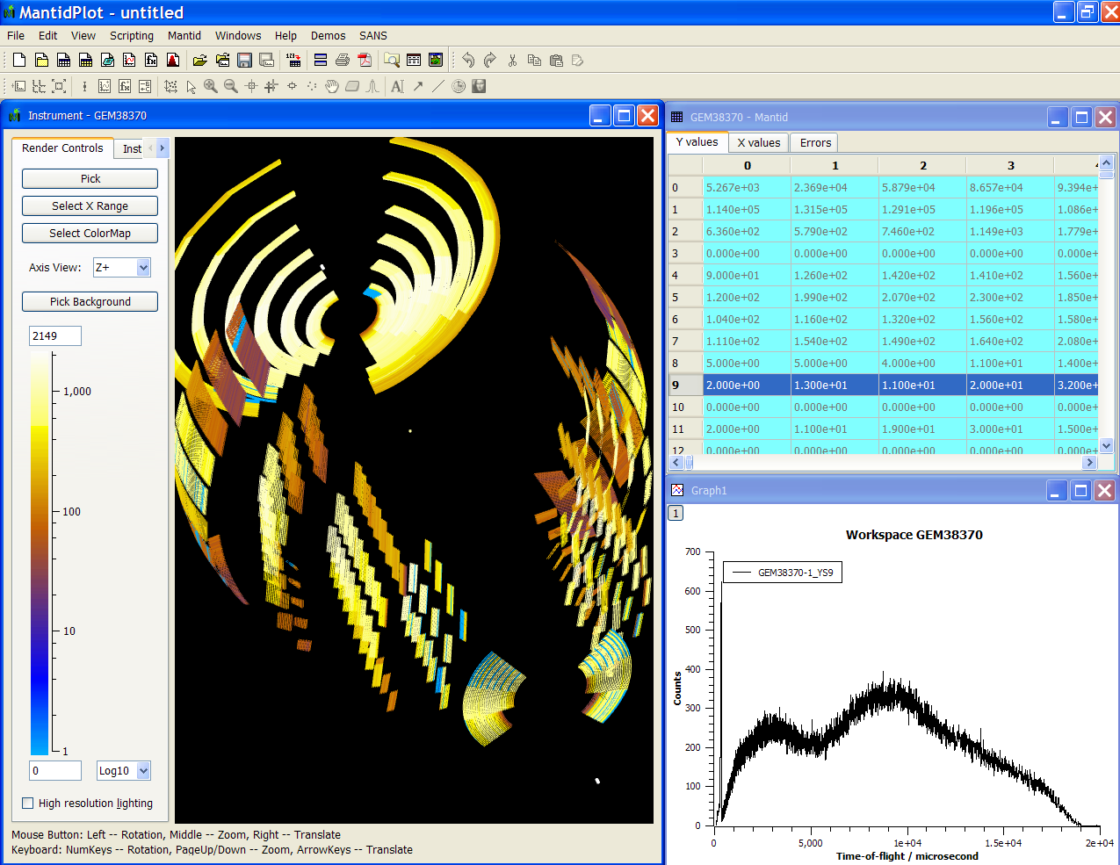
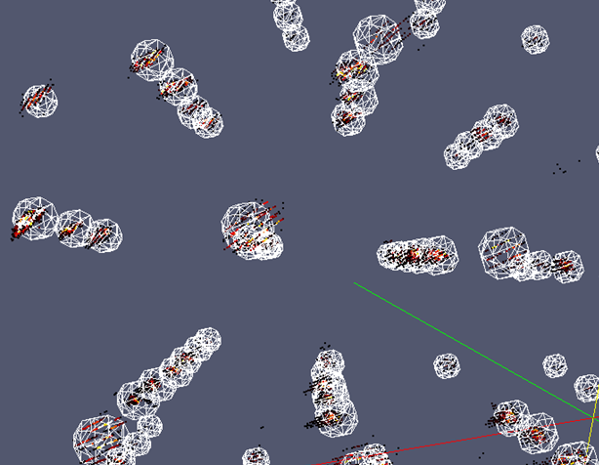
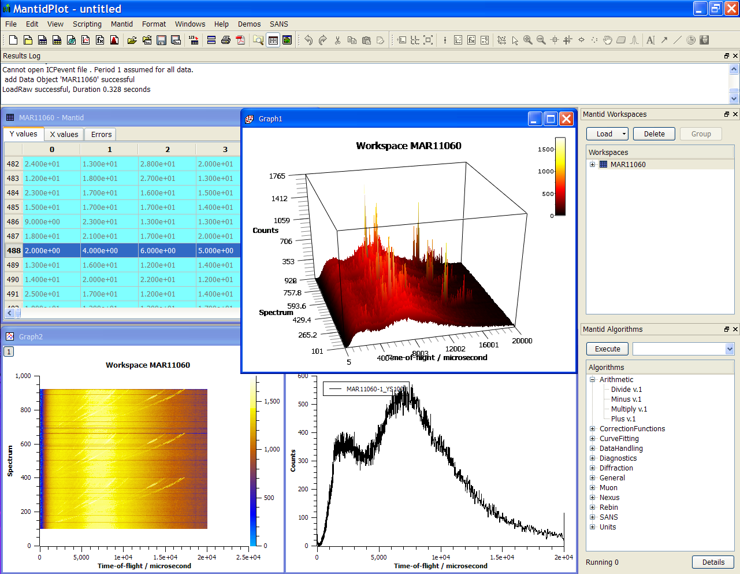
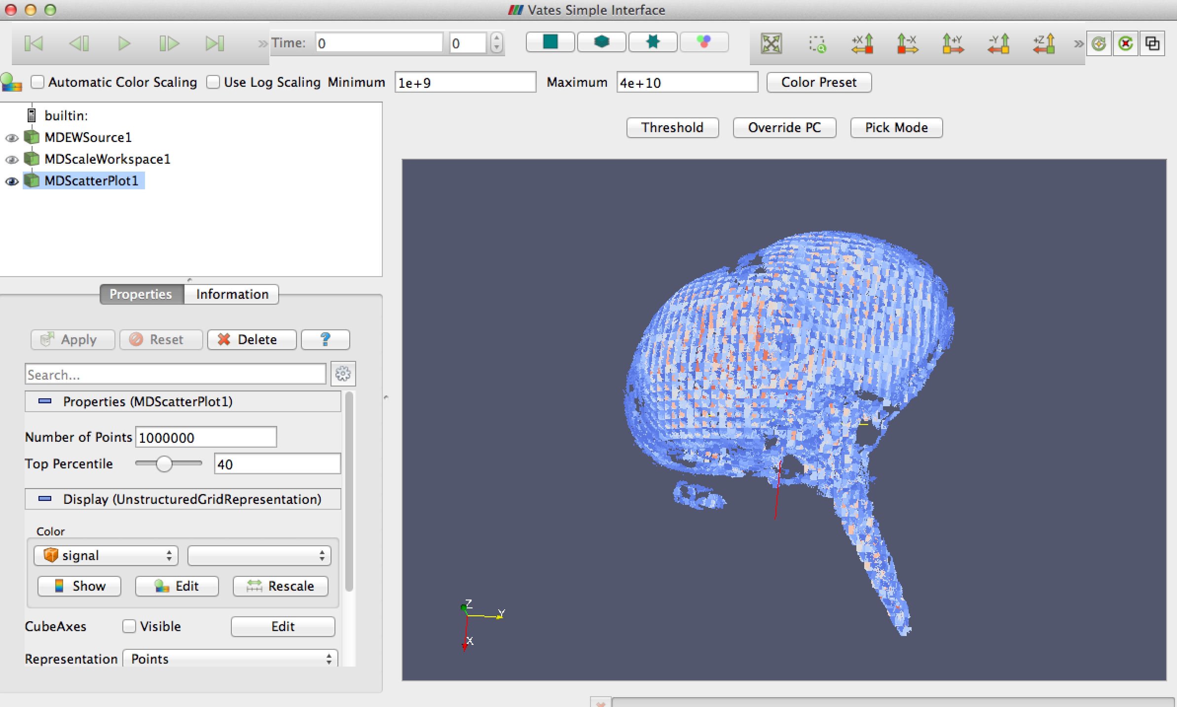
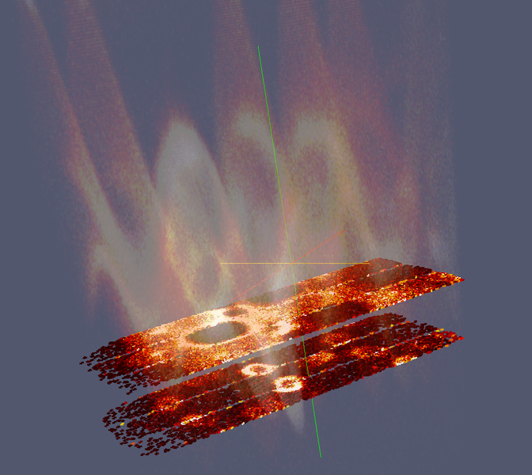
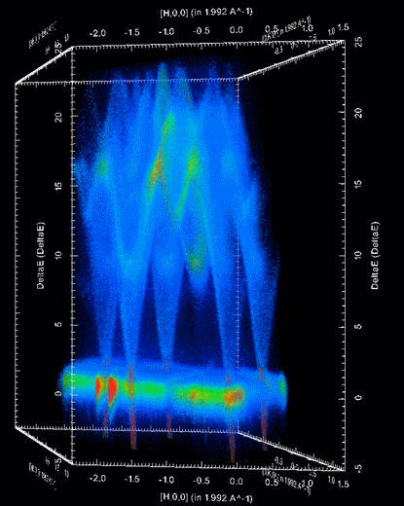

Document Control
This document is under document control. All members of the distribution list will receive updated copies whenever alterations are made. All other copies are uncontrolled.

Contributors
Name | Role | Company
Nicholas Draper | Author | Tessella

Document Approval
Name | Role | Company

Distribution
Name | Role | Company
Project Management Board Members | Recipient | STFC & ORNL
Mantid Project Repository | Filing | STFC & ORNL

Revision History
Author | Issue | Date | Description
Nicholas Draper | V1.R1.M0 | 31-Mar-2014 | 1st version written

References
Document | Ref | Date | Details and Version
Project Specification | [PS] |  | https://github.com/mantidproject/documents/blob/master/Project%20Management/ProjectSpecification.doc?raw=true
Stakeholder Plan | [SP] |  | https://github.com/mantidproject/documents/blob/master/Project%20Management/StakeholderPlan.doc?raw=true
Risk Register | [RR] |  | https://github.com/mantidproject/documents/blob/master/Project%20Management/RiskRegister.xls

Table of Contents
1 Introduction 3
2 Minutes of the previous meeting 4
3 Project Documentation 4
4 Project Status 4
5 Election of Chairman, or extension of current chairperson 5
6 What to do with external mantid interfaces 5
7 Is there a need to replace Mantidplot, or extend it (support for Matplotlib) 5
8 Plans for scientific steering committee meeting and developer meeting at ISIS 5
9 Update on progress of SSC requirements 6
10 Future Release Dates 7
11 Appendix A: Metrics 8
12 Appendix B: External project screenshots 10

Introduction

Purpose of this Document
This report details the current state of the Mantid project and presents the agreed agenda for discussion. The project management board will use the information in this report as a basis for the meeting.

Scope of this Document
The scope of this document is limited to the Mantid project, both for progress up to the meeting of the Project management board, and plans for the future.

Context of this Issue
This is the twelfth project management report to the Mantid project management board and will provide input to the meeting.

Minutes of the previous meeting
The minutes of the previous meeting are available here:
https://github.com/mantidproject/documents/blob/master/Project-Management/PMB/Minutes/PMCMinutes3rdApril14.docx?raw=true

Project Documentation
The project documentation is available through the links below. The Risk Register has been reviewed and updated. The other documents have not been changed since the last PMB meeting.

Stakeholder Plan:
https://github.com/mantidproject/documents/blob/master/Project%20Management/Stakeholder Map.doc?raw=true
No changes this time

Risk Register:
https://github.com/mantidproject/documents/blob/master/Project%20Management/RiskRegister.xls
No changes this time

Project Status

Development Progress
Since the last PMB meeting in April 2014 we have completed one development iterations and released new versions of Mantid on the following dates:
- v3.2 14th July 2014
Development continues at a good pace: see the project metrics in section 11.2.

Election of Chairman, or extension of current chairperson
We need to elect a new chairperson, or agree to extend Thomas’ tenure as Chairperson.

Agreement of PMB seats per facility
We agreed to consider the contribution over the last 12 months by each facility to decide how many PMB voting seats each facility should get for the following year. I have included some metrics on Ticket completion and code commits in the appendix 11.3, but the clear message is that both members are contributing highly, and I suggest we continue with 3 seats each for the following year.

What to do with external mantid interfaces
Some interfaces (mSlice and QuickNXS, screenshots are in section 12) are being built outside of the Mantid project, but making use of the framework. This has advantages and disadvantages. We should discuss how to continue.

Advantages:
- Development might progress quicker by not conforming to Mantid standards and ways of working
- Staff with less knowledge of Mantid internals may be able to contribute
- It is good that the benefits of Mantid can be used by external projects

Disadvantages:
- The Mantid team cannot provide support to these external projects
- External projects are less likely to contribute improvements to the Mantid framework core
- The look and feel of external projects is likely to differ to the core Mantid user interfaces
- Users might expect to find documentation and help in the Manti repositories, but it is unlikely to be available.
- Users will judge Mantid based on the stability and functionality of external projects
- External projects may still push additional work to the core Mantid team

Is there a need to replace Mantidplot, or extend it (support for Matplotlib)
QuickNXS uses Matplotlib extensively; Mantidplot uses QWT to perform the same plotting. At present Mantid does not bundle Matplotlib due to the increase it would cause to the installer size.
We could:
- Maintain Manitdplot using QWT, and rewrite user interfaces that merge into it as necessary.
- Adjust Mantidplot so that it can plot by either QWT or Matplotlib, This would increase the maintenance overhead, and possible cause confusion as some graphs may not behave as others do.
- Convert Mantidplot to use MatPlotLib for all plotting. This approach would require investigation in order to assess feasibility and likely effort involved. It is not clear at this point is we can replicate the interaction when fitting, or within the instrument view using Matplotlib

Plans for scientific steering committee meeting and developer meeting at ISIS
We need to arrange dates at least to allow the ORNL travel request process to start.

Update on progress of SSC requirements

Completed in Release 3.2
id | summary | status | owner
8919 | Better usage examples in documentation | closed | Anders Markvardsen
8909 | Tiled Graph Displays | closed | Roman Tolchenov
8913 | History depth / extracting scripts | closed | Samuel Jackson
8917 | Documentation maintenance | closed | Karl Palmen
8922 | Load performance History | closed | Samuel Jackson
8923 | Plotting improvements | closed | Martyn Gigg
8932 | Mslice interface - Design | closed | Steve Miller
9300 | Correct handling of Fast logs in time slicing | closed | Wenduo Zhou

Planned for Release 3.3
id | summary | status | owner
8916 | Improve vates visualisation defaults | assigned | Peter Peterson
9105 | New MD normalization framework | inprogress | Andrei Savici
8911 | MultiDataFitting | assigned | Roman Tolchenov
8912 | Python Command Line interface improvements | assigned | Owen Arnold
8914 | Masking redesign - design document | assigned | Nick Draper
8915 | GUI design guidelines | assigned | Martyn Gigg
8918 | Algorithm naming conventions/standards | assigned | Martyn Gigg
8920 | Load performance HDF5 | assigned | Peter Peterson
8924 | Repo. for instrument files | assigned | Peter Peterson
8925 | Specify API for instrument control | assigned | Nick Draper
8926 | Multiple scattering sub project - outline document | assigned | Jon Taylor
8927 | Verification of the ISIS quick scripts (with liquids) | verify | Jean Bilheux
8928 | Unify ISIS refl simple UI to work everywhere | assigned | Jean Bilheux
8929 | refl benchmarks | assigned | Jean Bilheux
8930 | Fix rectangular detector issues | assigned | Vickie Lynch
8945 | Measure loading performance for large files and optimize | verify | Nick Draper
9295 | Artur GUI working with Liquids (outside of mantid if necessary) | new | Jean Bilheux
9304 | Inelastic planning tools - Porting existing tools | new | Peter Peterson
9307 | Improvements to VATES User expreience | assigned | Peter Peterson
9308 | Include different resolution models for quantification | assigned | Jose Borreguero
9718 | Outstanding Documentation Maintenance | assigned | Karl Palmen

Future Release Dates
The planned release dates for the future are:
- v3.3 31st October 2014
- v3.4 30th January 2015
- v3.5 1st June 2015
- v3.6 1st October 2015
- v3.6 30th January 2016
This does not include patch releases.

Appendix A: Metrics

Project Metrics
The code metrics are independently generated and displayed here
http://www.openhub.net/p/Mantid/analyses/latest/languages_summary
Total Lines : | 2,463,389 |  | Code Lines : | 1,863,022 |  | Percent Code Lines : | 74.5%
 |  |  | Total Comment Lines : | 347,492 |  | Percent Comment Lines : | 14.1%
 |  |  | Total Blank Lines : | 279,875 |  | Percent Blank Lines : | 11.4%

Ticket completion rate
Development on Mantid is performed in three month iterations, each of which ends with an official release of the software. Longer pieces of work sometimes have to span a development iteration in which case that piece of work appears as completed only in the iterations when it becomes available to the users.
The patch releases (2.x.x) are very much smaller and are used to solve issues that become apparent after the main release or release urgent improvements that have recently been added.

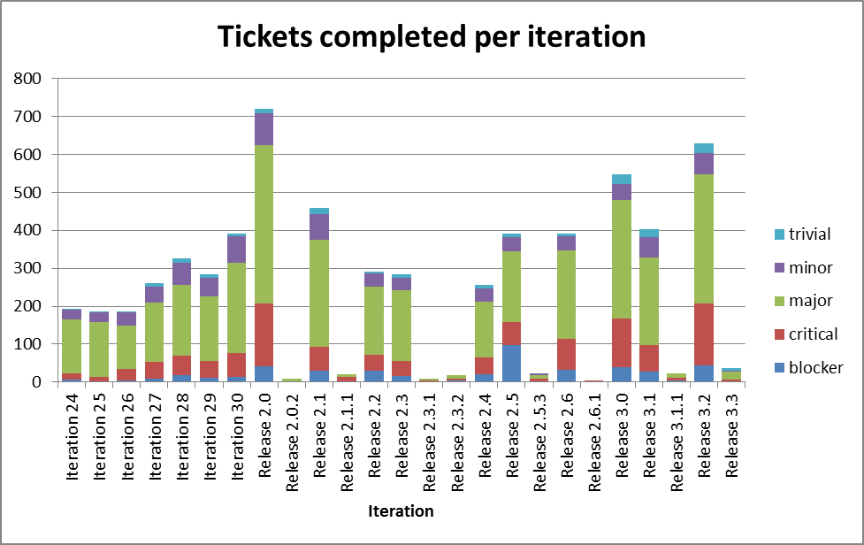
The Release 2.0 appears out of proportion beacause it covered two development iterations (6 months of effort). Release 3.2 covered 4 months of development effort rather than 3.

Ticket and Commit metrics over the last 12 months

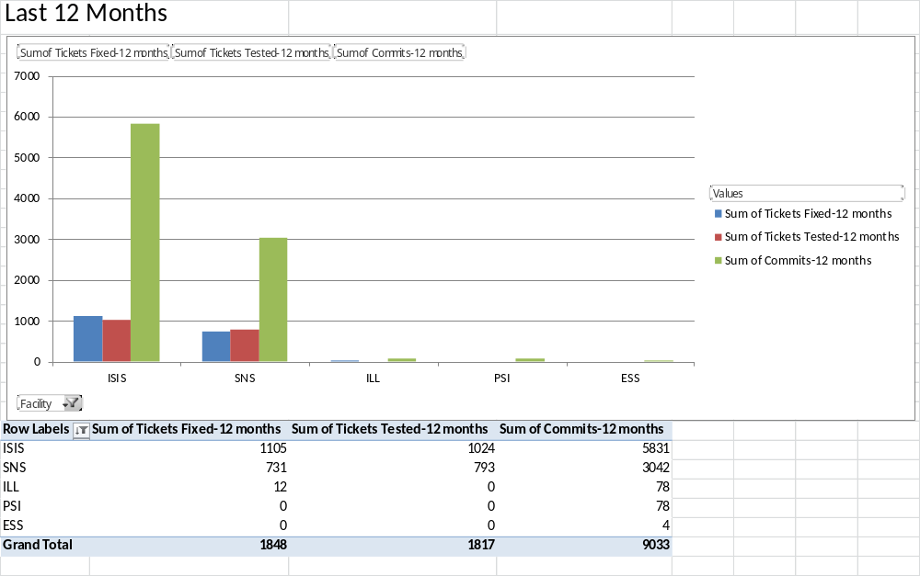

Appendix B: External project screenshots

QuickNxs
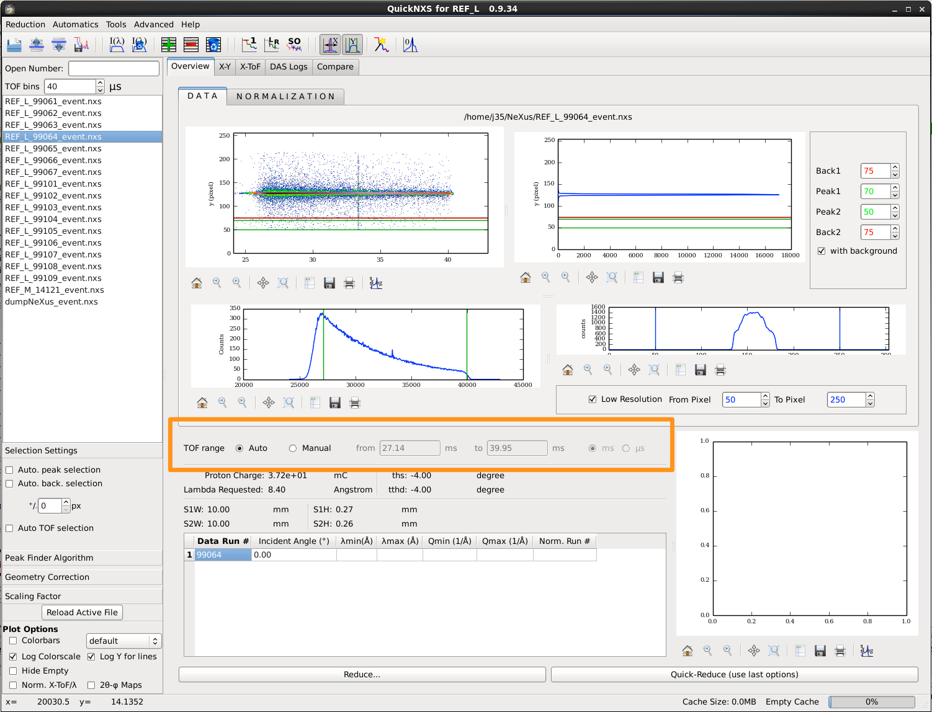

MSlice
